# COMP3500: Project 2 How to install and compile OS/161?

README

After installed VirtualBox on my Windows machine, I installed CentOS 6.5 on VirtualBox. Next, I successfully installed cs161-binutils-1.4 and cs161-gcc-1.5.tar. Unfortunately, I encountered an error "configure: error: no termcap library found". Installing the missing package can solve this problem. Please use the following command to install the package:

yum install ncurses-devel

You don't have to install CentOS 6.5, because I believe that you can install all the OS161 tools on CentOS 7. You don't have to install VirtualBox neither. Nevertheless, if you decide to install CentOS on VirtualBox, please refer to my installation log below.

1. Download CentOS 6.5 CD ISO image file

Tested on Windows7 <http://archive.kernel.org/centos-vault/6.5/isos/i386/>

Tested on McOS <http://getintopc.com/softwares/operating-systems/centos-6-5-free-download/>

2. Download VirtualBox

<https://www.virtualbox.org/wiki/Downloads>

3. Installation of CentOS in VirtualBox

<http://teaching.idallen.com/cst8207/14f/notes/000_centos_virtualbox_install.html>

4. Install CentOS

4.1 Important! When power on (boot) your virtual machine, you should see the CentOS installation screen. You must click in the window and use the arrow keys to stop the Automatic boot.

4.2 Important! After the installation is done, please reconfigure the Boot Order. Hard disk first followed by CD/DVD.

5. Create a user account in CentOS and Login CentOS using your newly created account

6. Become a root using $su and Install:

# yum -y install gcc

# yum -y install gcc-c++

# yum -y install vim-enhanced

# yum -y install emacs

# yum -y install gdb

# yum -y install ethtool

# yum -y install hdparm

# yum -y install pciutils

# yum -y install file

# yum install ncurses-devel

Important! If you don’t install the ncurses-devel package, you will receive an error message when you install cs161-gdb-1.5 (see also step 10).

7. Download OS161 tarballs

7.1 Create the cs161 directory in your home directory

7.2 Download the following tarballs from Canvas and save them in your cs161 directory

cs161-binutils-1.4.tar

cs161-gcc-1.5.tar

cs161-gdb-1.5.tar

sys161-1.14.tar.gz

os161-1.10.tar

8. Install cs161-binutils-1.4

cd cs161

tar vfzx cs161-binutils-1.4.tar

cd cs161-binutils-1.4

./toolbuild.sh

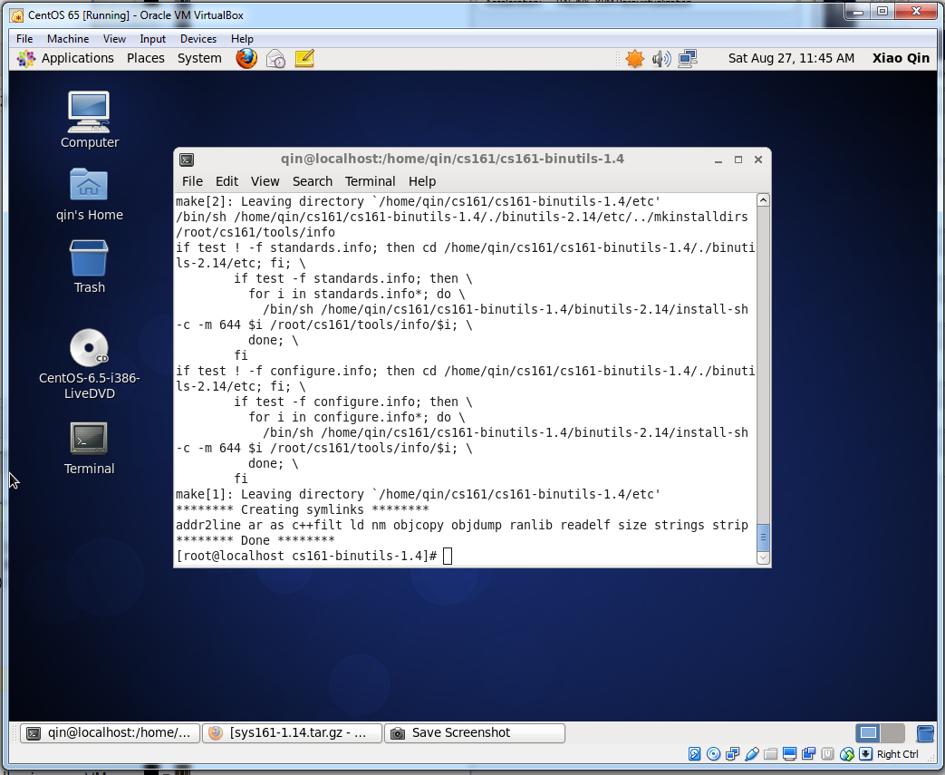

9 Build the cross compiler

cd ~/cs161

tar vfxz cs161-gcc-1.5.tar

cd cs161-gcc-1.5

./toolbuild.sh

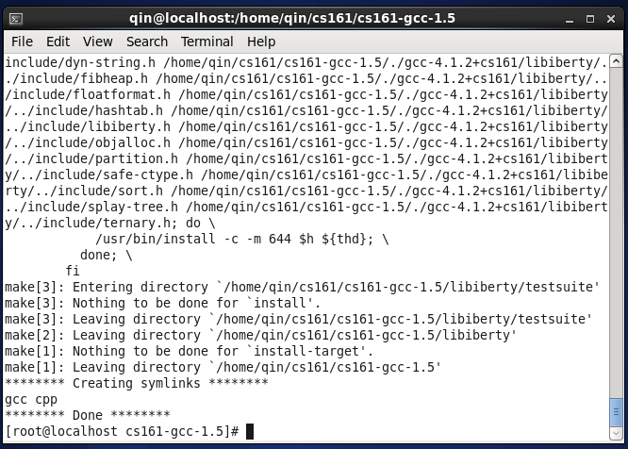

10. Build the special gdb (works)

cd ~/cs161

tar vfxz cs161-gdb-1.5.tar

cd cs161-gdb-1.5

./toolbuild.sh

**Error Message:** configure: error: no termcap library found

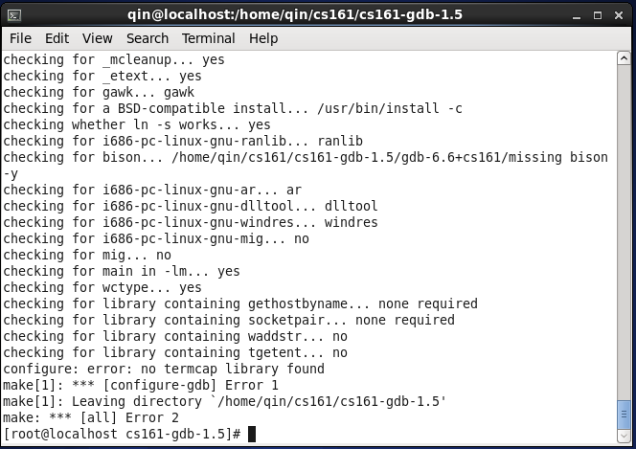

Install the missing ncurses-devel package:

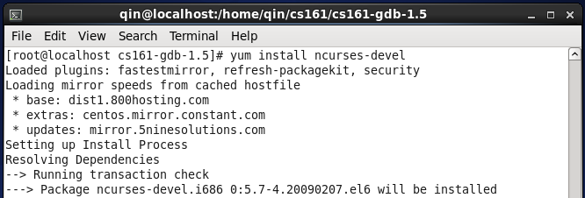

Successfully installed cs161-gdb-1.5

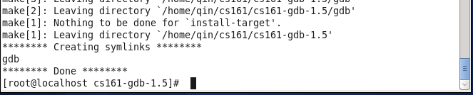

11. Build the sys161 emulator

cd ~/cs161

tar vfxz sys161-1.14.tar.gz

cd sys161-1.14

./configure mipseb

make

make install

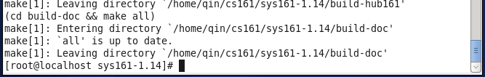

12. Install os161

12.1 Unpack os161-1.10.tar

tar xvfz os161-1.10.tar.gz

12.2 Configure your tree for the machine on which you are working. We assume that you work in the directory ~/cs161. Please note that if you intend to work in a directory that's not ~/cs161 (which you will be doing when you test your later submissions), you will have to use the –ostree option to specify a directory in which you are working. ./configure –help explains the other options.

cd ~/cs161/src

./configure

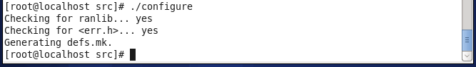

12.3 Configure a kernel named ASST0.

cd ~/cs161/src/kern/conf

./config ASST0

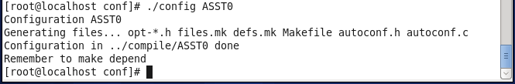

12.4 Build the ASST0 kernel. (cs161/src/compile). Use ‘echo $PATH’ to check your $PATH.

export PATH=~/cs161/bin:$PATH

cd ../compile/ASST0

make depend

make

12.5 Install the ASST0 kernel.

% make install

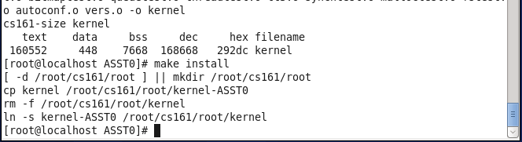

12.6 Now also build the user level utilties.

cd ~/cs161/src

make

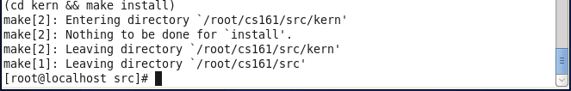

**13. RUN OS161:** Change into your root directory.

%cd ~/cs161/root

Run the machine simulator on your operating system.

%./sys161 kernel

Important! If you receive the following error message “Sys161: Cannot open config file sys161.conf”, you should download the file [sys161.conf](http://sys161.conf/) from Canvas and place it in your OS/161 root directory (~/cs161/root).

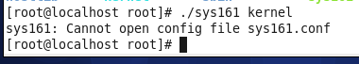

If you successfully run os161, you will have:

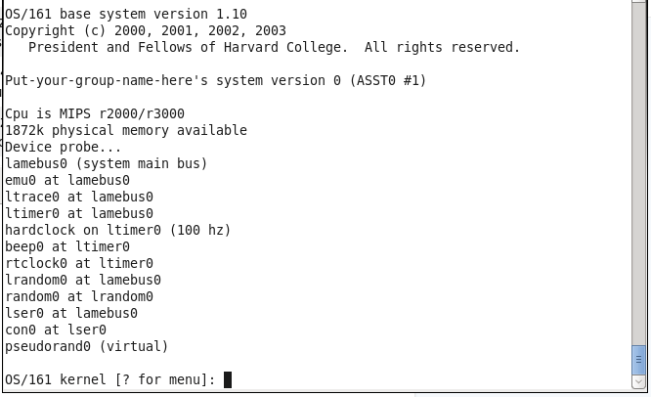

At the prompt, type p /sbin/poweroff <return>. This tells the kernel to run the "poweroff" program that shuts the system down.

